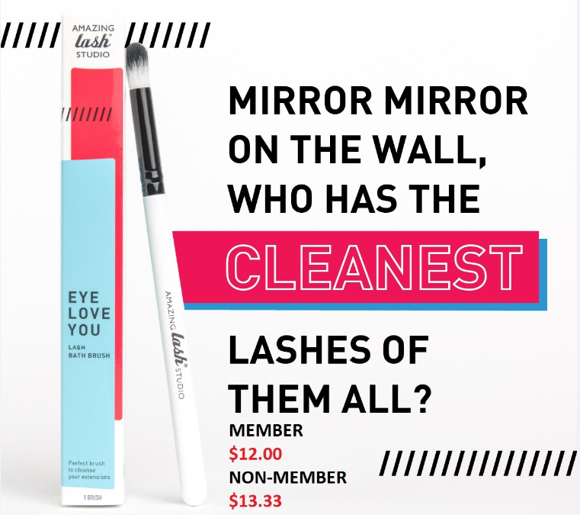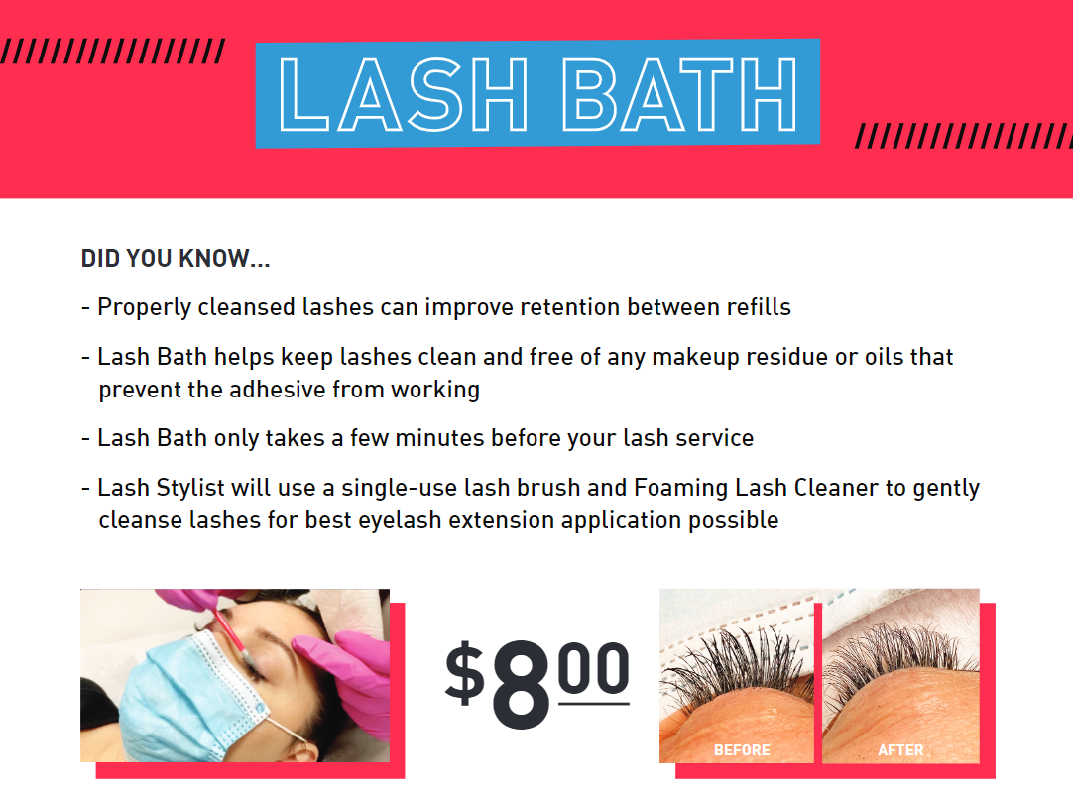

**$52 VALUE**

**ONLY $30**

*Member Price

**Improve Lash Retention**

**GET A LASH BATH BRUSH & 5 LASH BATH SERVICES FOR ONLY $30**